Manage Local Linux Users and Groups

Objective
The objective of this project is to understand and perform Linux user and group management tasks. This includes creating users and groups, modifying accounts, understanding important system files, managing passwords, and administering local password policies.

Introduction
Linux is a multi-user operating system where multiple users can access system resources simultaneously. To maintain security and proper resource allocation, Linux uses user accounts and groups.
Each user account contains:
- Username
- User ID (UID)
Each group contains:
- Group Name
- Group ID (GID)
Linux users are classified into:
- Root User
- Service/System User
- Regular User

Types of Users in Linux
1. Root User
- Created automatically during Linux installation.
- Has complete administrative privileges.
- Can access and modify all files and services.

2. Regular User
- Created manually by the administrator.
- Used for routine tasks.
- Limited access based on permissions.

Understanding Important Linux User Files
- Cat /etc/passwd
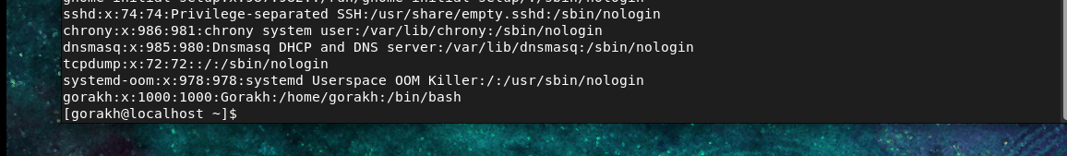
This file stores user account information.
Example:
gorakh:x:1002:1002::/home/gorakh:/bin/bash
Fields Description
Field | Description
gorakh | Username
x | Password placeholder
1002 | UID
1002 | GID
(blank) | Comment/GECOS
/home/gorakh | Home Directory
/bin/bash | Default Shell
Command
cat /etc/passwd

- /etc/shadow File
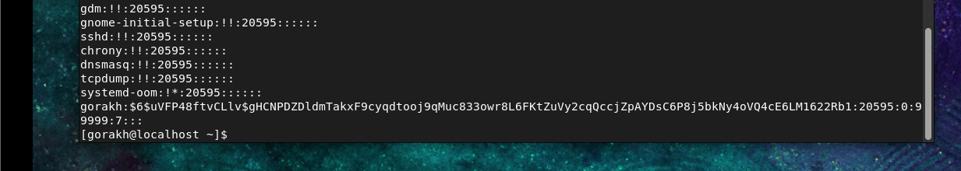
Stores encrypted passwords and password aging details.
Example:
gorakh:$6$abcd1234:19348:0:99999:7:::
Fields Description
Field | Description
gorakh | Username
$6$abcd1234 | Encrypted Password
19348 | Last Password Change
0 | Minimum Days
99999 | Maximum Days
7 | Warning Days
(blank) | Inactive Days
(blank) | Expiry Date
Command
cat /etc/shadow

Practical Tasks
1. Create User Accounts
Add New User
useradd vishant
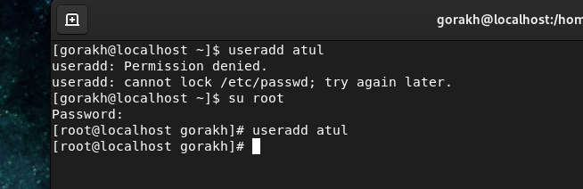
Cat/etc/passwd
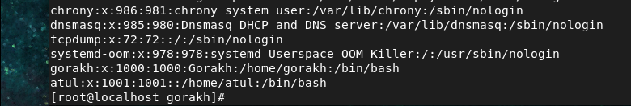

Create User with Specific UID
useradd -u 1010 meghraj
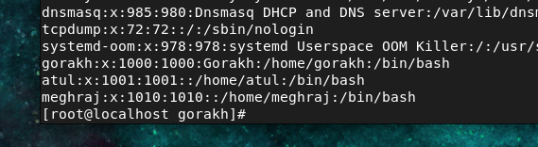
Create User with Specific Group
useradd -g 1000 tulika
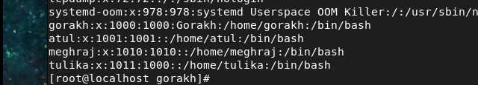
Add Comment for User
useradd -c "system admin" kuldeep
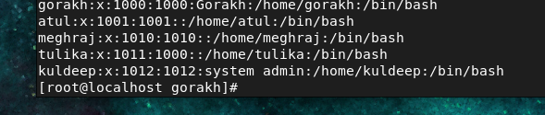
Change Home Directory During Creation
useradd -d /home/itadmin rushi
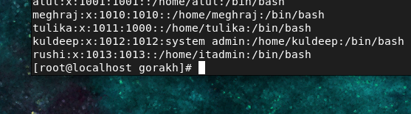
Verify User Entries
cat /etc/passwd

2. Delete User Accounts
Delete User Only
userdel kuldeep
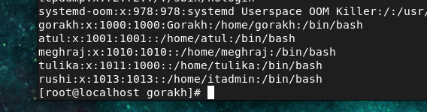
Delete User with Home Directory
userdel -r meghraju
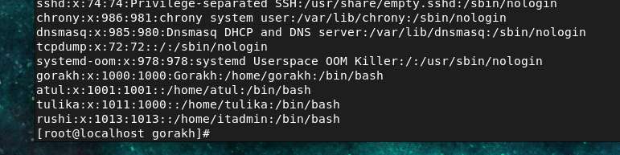

3. Modify Existing Users (usermod)
Add or Modify Comment
usermod -c "This is test user" rushi
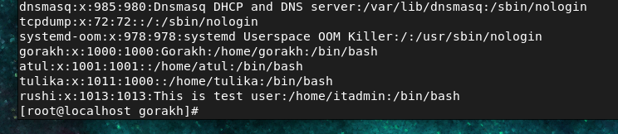
Change Home Directory
usermod -d /home/test rushi
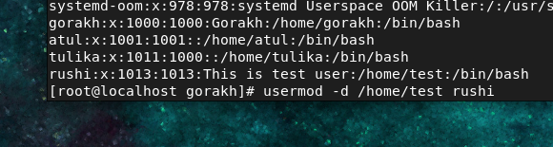g

Change Primary Group
usermod -g 1001 rushi

Change Username
usermod -l tiwari rushi
useradd -l newname oldname
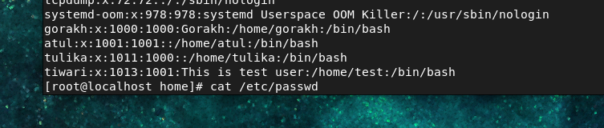

Change UID
usermod -u 1010 tiwari
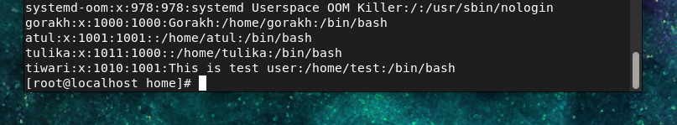

4. Change User Passwords
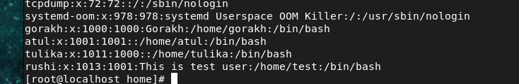Change Password Interactively
passwd Tiwari
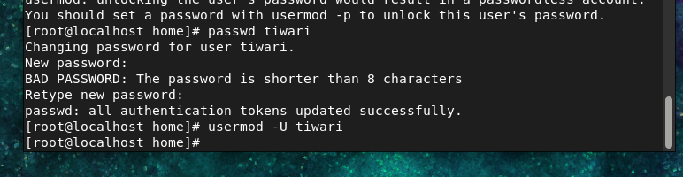

5. Understanding /etc/group File
Stores group information.
Example
editors:x:2002:damon,tyler
Fields Description
Field | Description
editors | Group Name
x | Password Placeholder
2002 | GID
damon,tyler | Group Members
Command
cat /etc/group
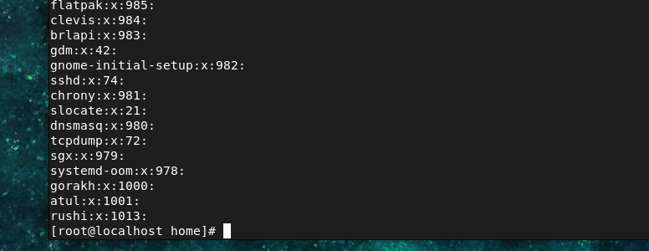

6. Create and Delete Groups
Create New Group
groupadd gauresh
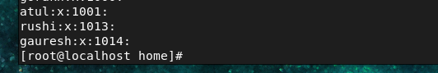

Create Group with Specific GID
groupadd -g 1016 gauresh1
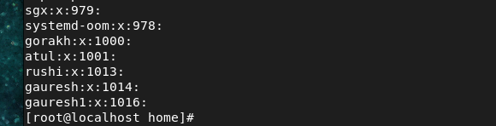

Delete Group
groupdel gauresh1
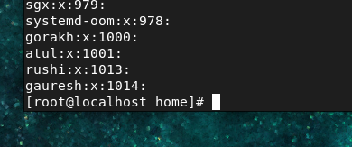

7. Modify Groups
Change Group Name
sudo groupmod -n jagurti cloudgroup
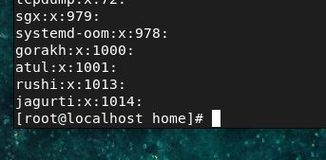
Change Group GID
groupmod -g 1012 jagurti
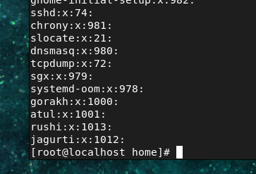

Verification Commands
Verify Users
cat /etc/passwd
Verify Password Details
cat /etc/shadow
Verify Groups
cat /etc/group

1️)gpasswd – Group Administration
The gpasswd command is used to manage groups in Linux.
It modifies:
- /etc/group
- /etc/gshadow
➤ Create a group
groupadd itdept

Check group:
cat /etc/group

➤ Add user to a group
gpasswd -a username groupname
gpasswd -a gorakh2 itdept

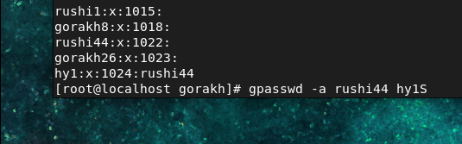
Check:
cat /etc/group

➤ Remove user from a group
gpasswd -d vishant itdept

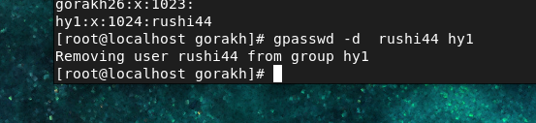
Check again:
cat /etc/group
Tip: User must log out & log in again to apply group changes.

2️)chage – Password Expiry Management
chage = change age
Used to control password expiry and account aging.

➤ Show password expiry info
chage -l gorakh

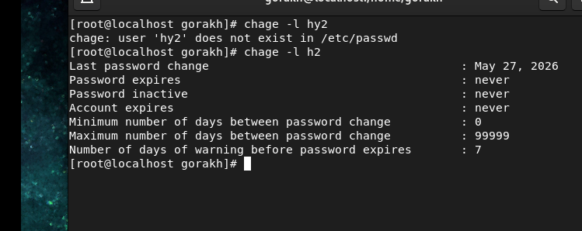

➤ Set minimum days between password change
chage -m 10 gorakh

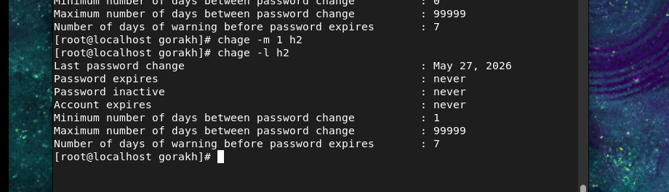

➤ Set maximum password validity
chage -M 730 u1

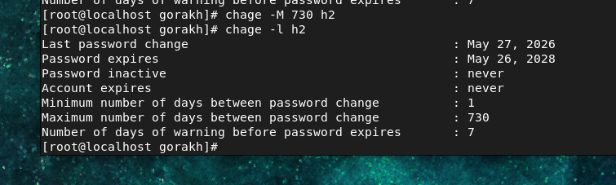

➤ Warning days before expiry
chage -W 5 u1

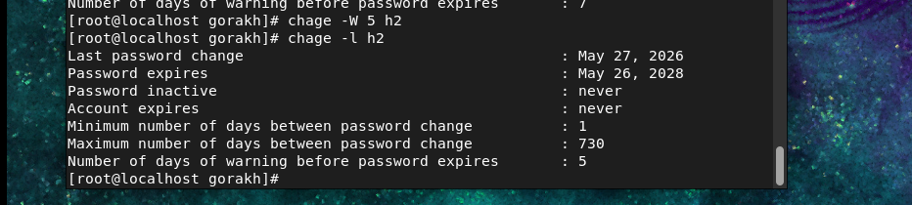

➤ Account inactivity period
chage -I 5 u1

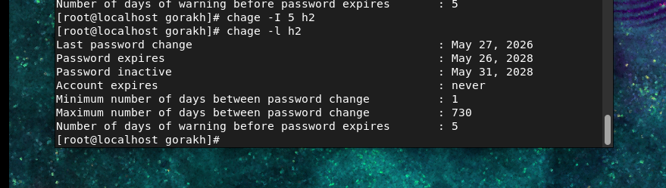

➤ Set account expiry date
chage -E 2026-12-14 u1

